Kayley Seow

Chapter 4

Pages 174 – 178

R4.1, 2, 3, 5, 7, 8, 10, 12, 13, 17, 18, 19, 23, 24

C++ Homework 10-4-2020

R4.1 Provide trace tables for these loops.

1. int i = 0; int j = 10; int n = 0;

while (i < j) { i++; j--; n++; }

0 10 0

1 9 1

2 8 2

3 7 3

4 6 4

5 5 5

1. int i = 0; int j = 0; int n = 0;

while (i < 10) { i++; n = n + i + j; j++; }

0 0 0

1 1 1

2 2 4

3 3 9

4 4 16

5 5 25

6 6 36

7 7 49

8 8 64

9 9 81

1. int i = 10; int j = 0; int n = 0;

while (i > 0) { i--; j++; n = n + i - j; }

10 0 0

9 1 8

8 2 14

7 3 18

6 4 20

5 5 20

4 6 18

3 7 14

2 8 8

1 9 0

1. int i = 0; int j = 10; int n = 0;

while (i != j) { i = i + 2; j = j - 2; n++; }

i is never equal to j.

R4.2 What do these loops print?

1. for (int i = 1; i < 10; i++) { cout << i << " "; }

1 2 3 4 5 6 7 8 9

1. for (int i = 1; i < 10; i += 2) { cout << i << " "; }

1 3 5 7 9

1. for (int i = 10; i > 1; i--) { cout << i << " "; }

10 9 8 7 6 5 4 3 2

1. for (int i = 0; i < 10; i++) { cout << i << " "; }

0 1 2 3 4 5 6 7 8 9

1. for (int i = 1; i < 10; i = i \* 2) { cout << i << " "; }

1 2 4 8

1. for (int i = 1; i < 10; i++) { if (i % 2 == 0) { cout << i << " "; } }

2 4 6 8

R4.3 What is an infinite loop? On your computer, how can you terminate a program that executes an infinite loop?

An infinite loop occurs when the conditions are coded in a way where the program will never exit the loop, meaning that it runs on forever. You can terminate a program with an infinite loop by either coding it correctly the first time or just shutting down your terminal.

R4.5 Write a program trace for the pseudocode in Exercise P4.9, assuming the input values are 47 –2 –5 0.

First = true

Minimum = 47 first = false

2 less than minimum, minimum = 2

50 greater than minimum

2 printed as minimum

R4.7 How often do the following loops execute? Assume that i is not changed in the loop body.

1. for (int i = 1; i <= 10; i++) ...

10

1. for (int i = 0; i < 10; i++) ...

10

1. for (int i = 10; i > 0; i--) ...

10

1. for (int i = -10; i <= 10; i++) ...

21

1. for (int i = 10; i >= 0; i++) ...

11

1. for (int i = -10; i <= 10; i = i + 2) ...

11

1. for (int i = -10; i <= 10; i = i + 3) ...

7

R4.8 Write pseudocode for a program that prints a calendar such as the following:

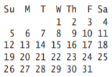

Cout << first line of days

Cout << second line

Counter to check if until 7, Boolean for newline

For loop that increments by 1 from 5 to 31

Cout inside forloop to print out dates and adequate spacing

R4.10 Write pseudocode for a program that reads a sequence of student records and prints the total score for each student. Each record has the student’s first and last name, followed by a sequence of test scores and a sentinel of –1. The sequence is terminated by the word END. Here is a sample sequence:



Provide a trace table for this sample input.

Read in the first name and last name, judging by where the spaces break the string

Boolean/if statement to check for -1

Declare variable for sum of scores, variable for input

Have a cin, and have that cin register to the input variable

While there is no -1, add input to the sum of scores

R4.12 Rewrite the following do/while loop into a while loop.

int n;

cin >> n;

double x = 0;

double s;

do

{

s = 1.0 / (1 + n \* n);

n++;

x = x + s;

}

while (s > 0.01);

int n;

cin >> n;

double x = 0;

double s;

while ( s > 0.01)

{

s = 1.0 / (1 + n \* n);

n++;

x = x + s;

}

R4.13 Provide trace tables of the following loops.

1. int s = 1; int n = 1; while (s < 10) { s = s + n; } n++;

1 1

2 1

3 1

4 1

5 1

6 1

7 1

8 1

9 1

9 2

1. int s = 1; for (int n = 1; n < 5; n++) { s = s + n; }

1 1

2 2

3 4

4 7

1. int s = 1; int n = 1; do { s = s + n; n++; } while (s < 10 \* n);

1 1

2 2

3 4

4 7

5 11

R4.17 Add a storyboard panel for the conversion program in Section 4.6 on page 154 that shows a scenario where a user enters incompatible units.

Noticeable groans from the user and tester. “Did you try cin.fail() yet?”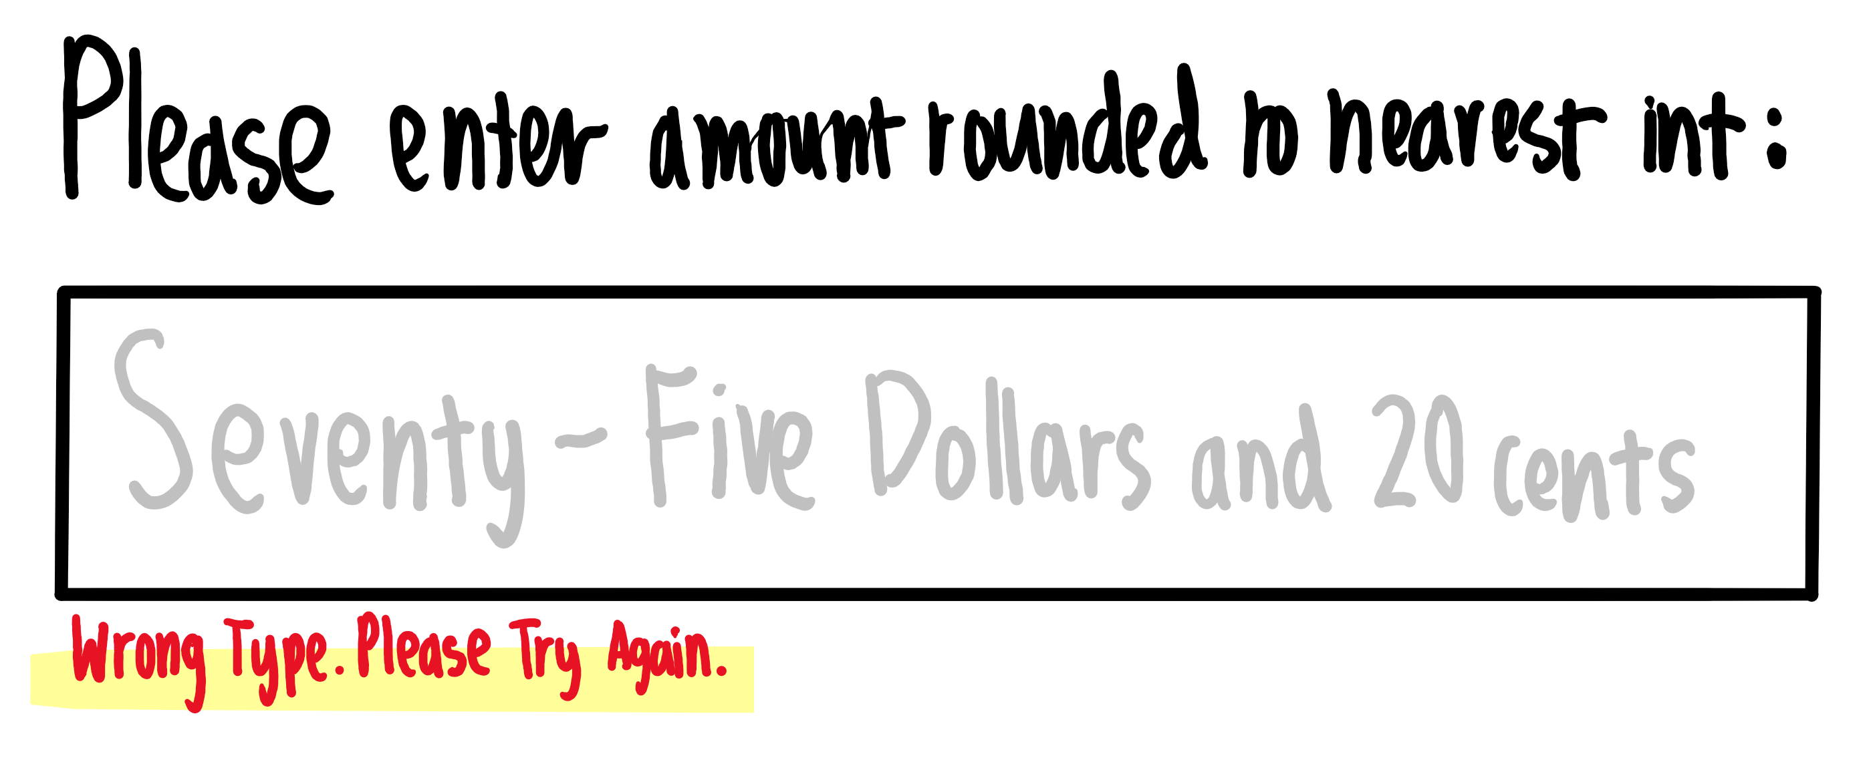R4.18 In Section 4.6, we decided to show users a list of all valid units in the prompt. If the program supports many more units, this approach is unworkable. Give a story board panel that illustrates an alternate approach: If the user enters an unknown unit, a list of all known units is shown.

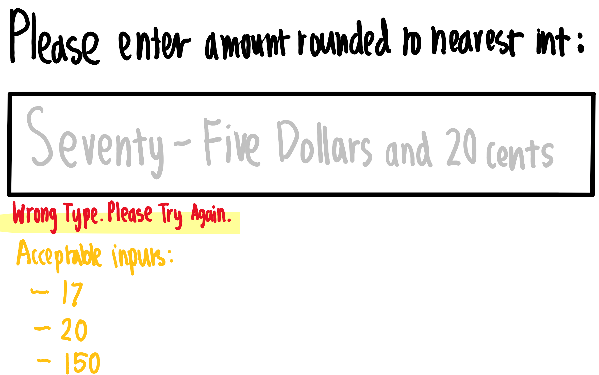

R4.19 Change the storyboards in Section 4.6 to support a menu that asks users whether they want to convert units, see program help, or quit the program. The menu should be displayed at the beginning of the program, when a sequence of values has been converted, and when an error is displayed.

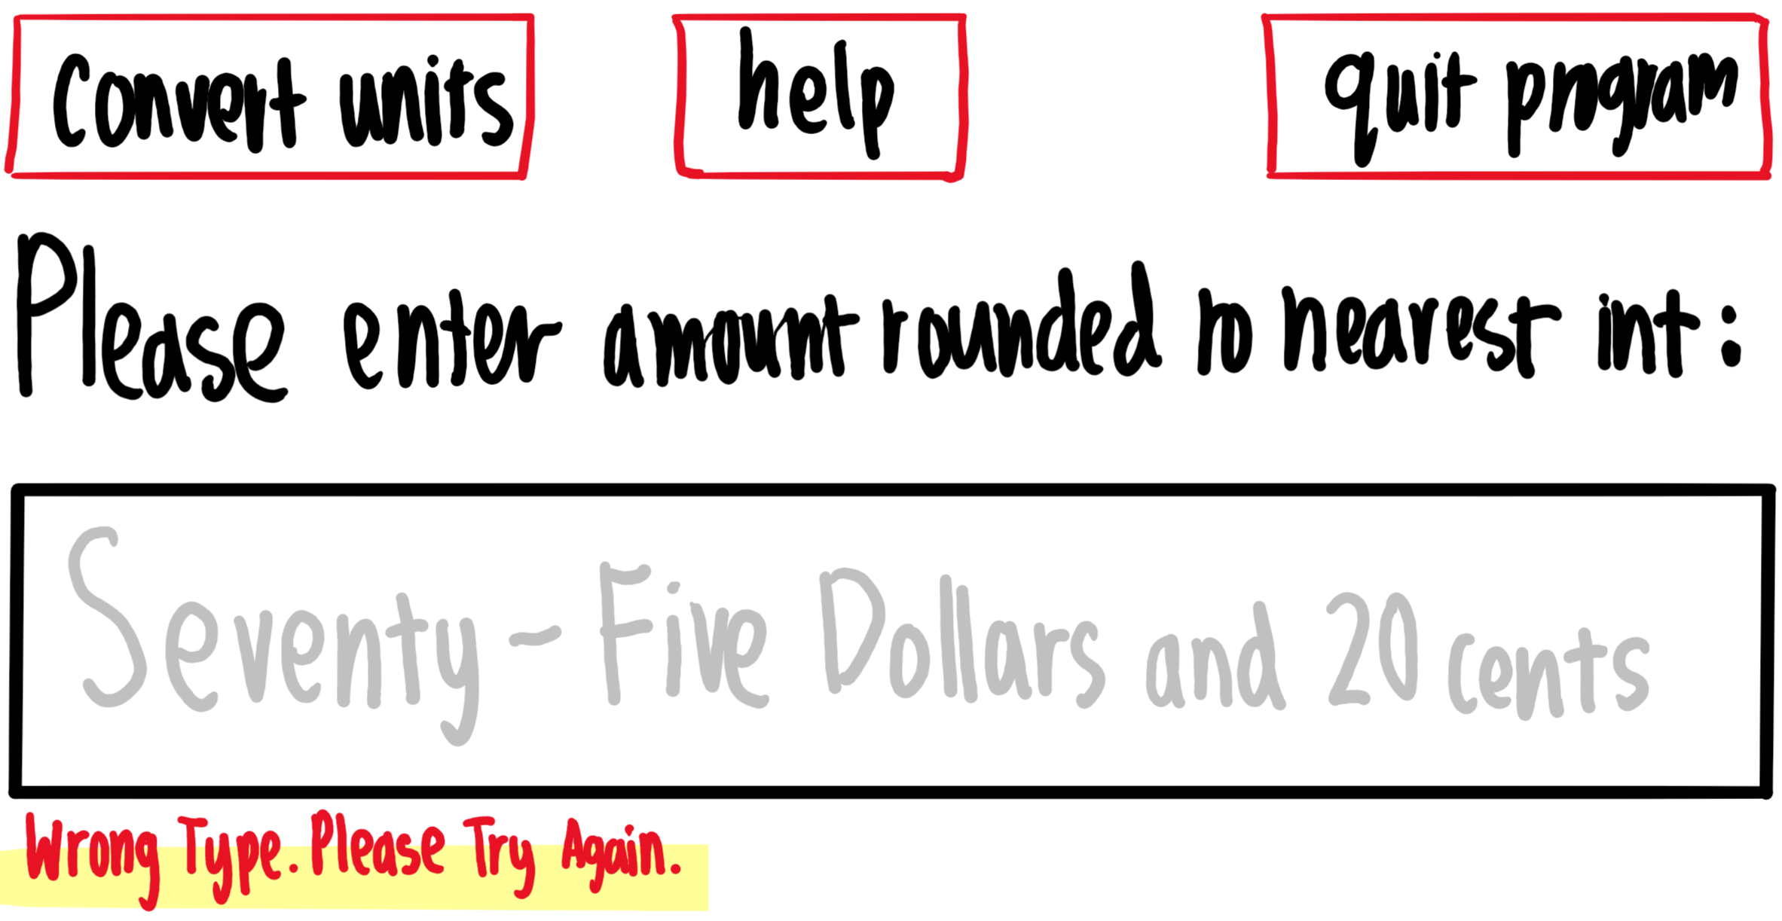

R4.23 The nested loops for (int i = 1; i <= height; i++) { for (int j = 1; j <= width; j++) { cout << "\*"; } cout << endl; } display a rectangle of a given width and height, such as \*\*\*\* \*\*\*\* \*\*\*\*. Write a single for loop that displays the same rectangle.

for(int i = 0; i < 3; i++)

{

cout << “\*\*\*\*\n”;

}

R4.24 Suppose you design an educational game to teach children how to read a clock. How do you generate random values for the hours and minutes?

I would make sure that the hours would never exceed 12, ant that minutes would never exceed 60.